# PROJECT REPORT

### FOOD FEAST ONLINE FOOD ORDERING SYSTEM

# Developers:

# Abdullah Sohail (SE-068)

# Anas Baig (SE-058)

**Purpose**

Food Feast.com is a simple website made for an imaginary restaurant named Food Feast providing the customers with the basic facility to order food online without any hassle.

**PROCESS MODEL**

The process model adopted for this project was simple waterfall model for these obvious reasons:

1. The project requirements were not so complex and well defined at the beginning
2. There was little chance of changing given requirements so other evolutionary process models were discarded.
3. The model is simple and convenient for smaller time frames.

**1. Communication Phase**

In the communication phase the requirements gathering process is initialized and the requirements are gathered from the concerned business entities. Different requirements are analyzed identified and documented. Having ambiguous requirements in this process model eventually leads to project failure since requirements are decided only once and finalized and are not changed nor new requirements are accommodated until the next iteration.

Business Requirements

The requirements from the perspective of restaurant owner are:

1. Offer convenience to its regular customers to order from their website.
2. Website aesthetics to attract new customers.
3. Allow people to find their address and location easily.

User Requirements

The requirements from the perspective of customer are:

1. Order food at any place from any place
2. Check restaurants servings without hassle of going to their location and finding the menu.
3. Find the price of dish online without any inconvenience.

Functional Requirements

1. Customer to be able to sign up.
2. Customer to be able to log in before making a purchase.
3. Customer to be able to filter the dishes according to category such as Chinese, desi and fast-food etc.
4. Customer to be able to add to cart the dishes he wants to order.
5. Customer to be able to view the cart and remove the items he wants to.
6. Customer to be able to adjust the quantity of items he wants to order.
7. Customer to be able to give different feedbacks while signing up.

Keeping in view the requirements of the system use cases of the system and system actors were identified. The use case diagram documents different use cases of the system which help in modeling the system accordingly.

Use Case Diagram

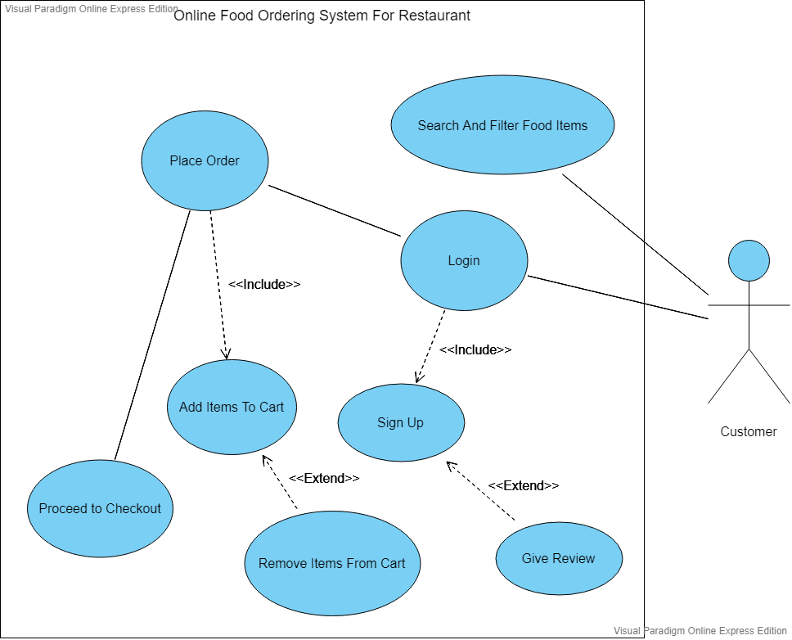

**2. Planning Phase**

The next phase after communication is the planning phase where project is scheduled, estimated and tracked. The project was scheduled with different stages with different milestones to be achieved during the time span of 2 weeks. A Gantt chart is produced to schedule the project.

For tracking purposes Git VCS and github is used to track the progress especially during the coding phase.

Git Commit Network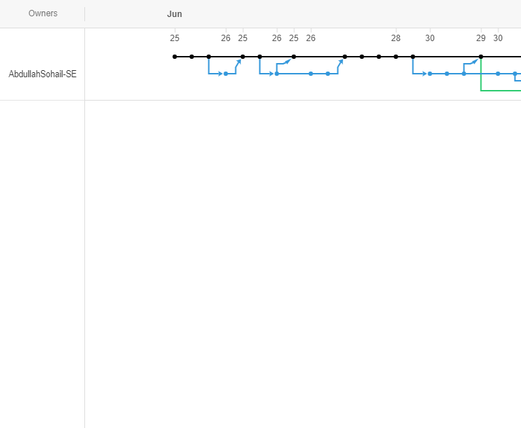

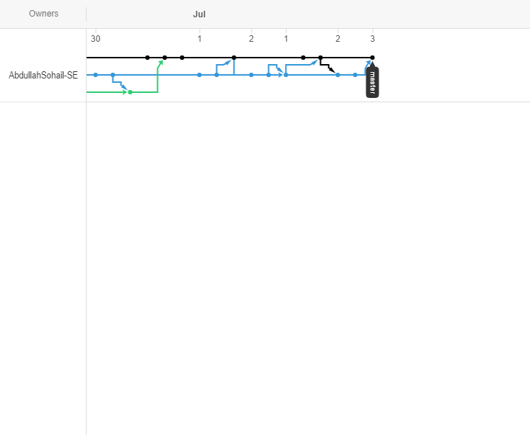

**3. Modeling Phase**

In the modeling phase the model of the website is made by keeping use case diagrams relevant also database is designed and first conceptual entity relationship diagram is made followed by logical and then physical ERD.

Logical Enhanced Entity Relationship Diagram

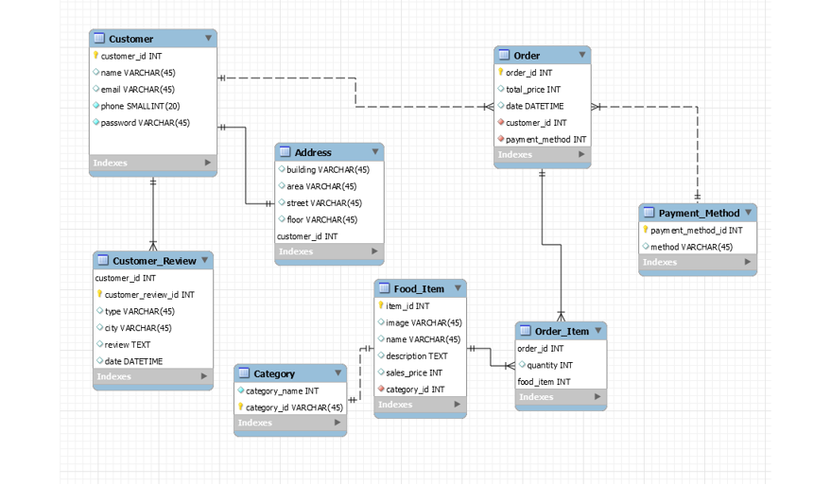

**4. Construction Phase**

The construction phase consists of two phases the coding phase and the testing phase. Different collections of technologies were used to code and program the website.

Front-End Languages, Frameworks and Architectures

1. HTML was simply used to produce the markup of the document.
2. CSS or cascading style sheets were used to style the documents.
3. SASS is a modern style sheet language with the advantage that it is also extended with SASS script which helps to style markup with the some functionalities of a scripting language. SASS script also comes in two scripting formats one being the simple SASS and other being SCSS which is being used in this project

The SASS is eventually compiled to CSS after being compiled by SASS compiler.

1. NPM package manager was used to install SASS compiler.
2. Bootstrap library was also used.
3. BEM or block element modifier architecture was employed for styling CSS.

Back-End Languages and Frameworks

1. The ASP.NET MVC is a web application framework developed by Microsoft, which implements the model–view–controller pattern was used for the back end system.
2. C# was used as a programming language to target .NET framework.

Visual Studio 2019 and Visual Studio Code were used as Integrated Development Environments for the Project.

**5. Deployment Phase**

The project is deployed locally through local host and is planned to be deployed on remote servers. The project is open to feedbacks to improve user experience.



Repository:

<https://github.com/AbdullahSohail-SE/Food-Feast>

Gantt Chart

